# System Design

System design is the process of defining the architecture, modules, interfaces, and data for a system to satisfy specified requirements. System design could be seen as the application systems theory to product development.

## Modeling Diagrams

Draw all UML Diagrams if you have decided to follow any Object Oriented Language for the Project Implementation.

## Use Case Diagram

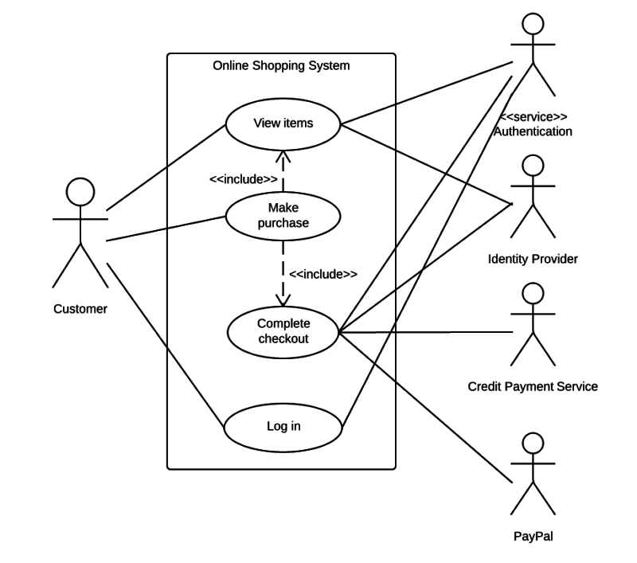

FIG 5 : QUICKPAY SHOPPING

## 1.2 Algorithm

Below are steps given to describe how the login processes in form of algorithm does.

Steps:

1. Start
2. Enter username
3. Server check username if match not found go to step 2.
4. Place your fingerprint
5. User already exit go to step 2.
6. Stop

## FLOWCHARTS

In the give flowchart (fig 6) it is shown that how a user request for a service and then the blink processes that request to authority server. Authority serve send nonfiction to service person and if he respond then authority servers notifies it to the user through the application. In case the service person does not responds the authority server can send request to another service persons too.

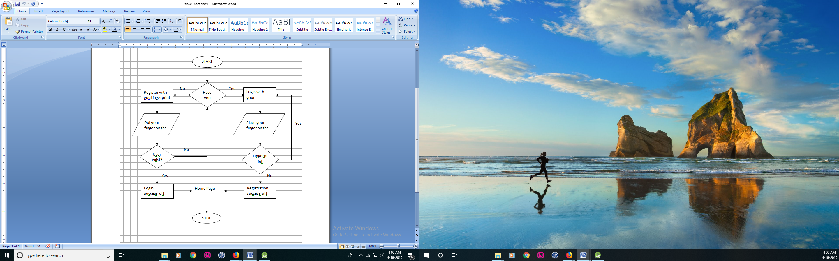

FIG-6 LOGIN FLOWCHART

## 1.4 Database Structure

We have used following Database for our application :

1. 000webhost : For Registration and Login purpose only

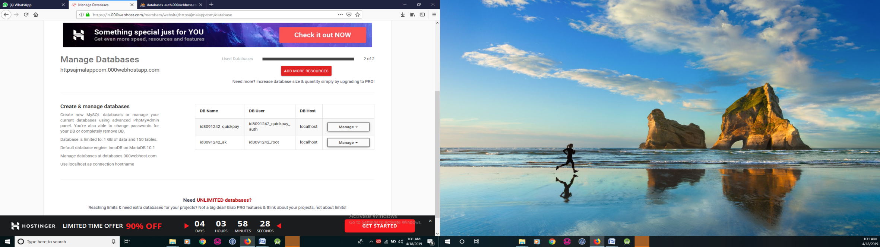

FIG-7 000webhost MANAGE DATABASE

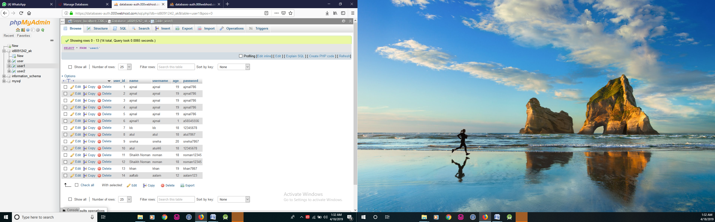

FIG-8 REGISTRATION TABLE

1. Firebase Database : For order related details

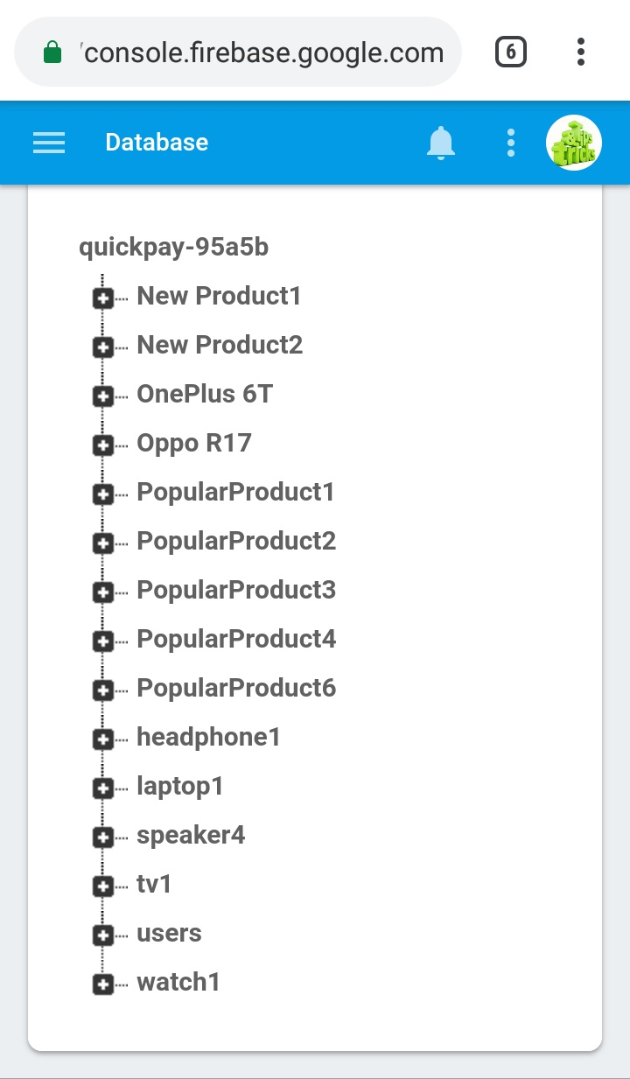 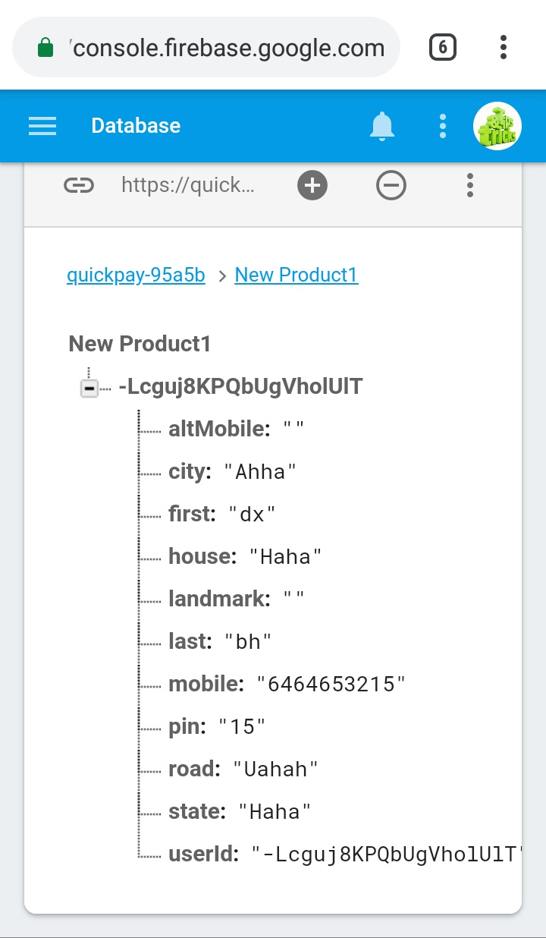

FIG-9 FIREBASE HOME FIG-10 NEW RPDUCT

DOCUMENT

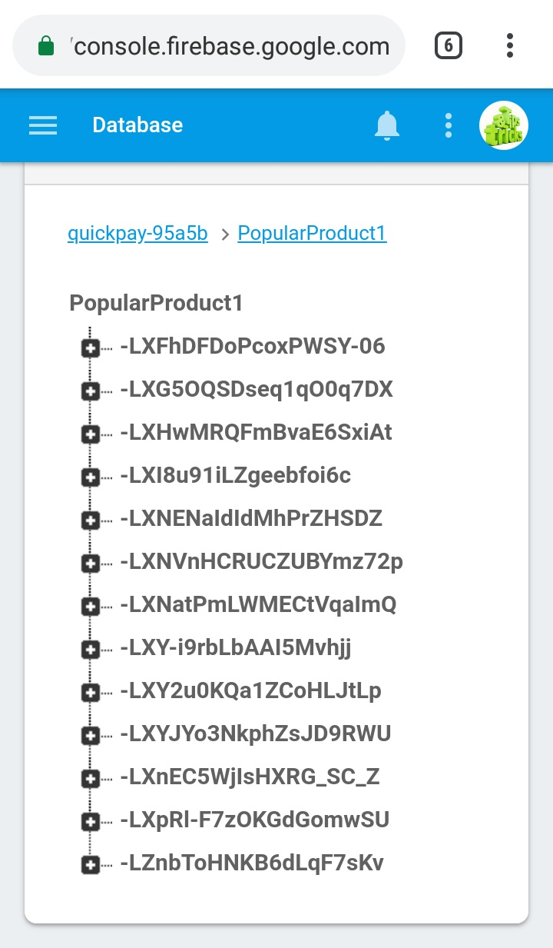 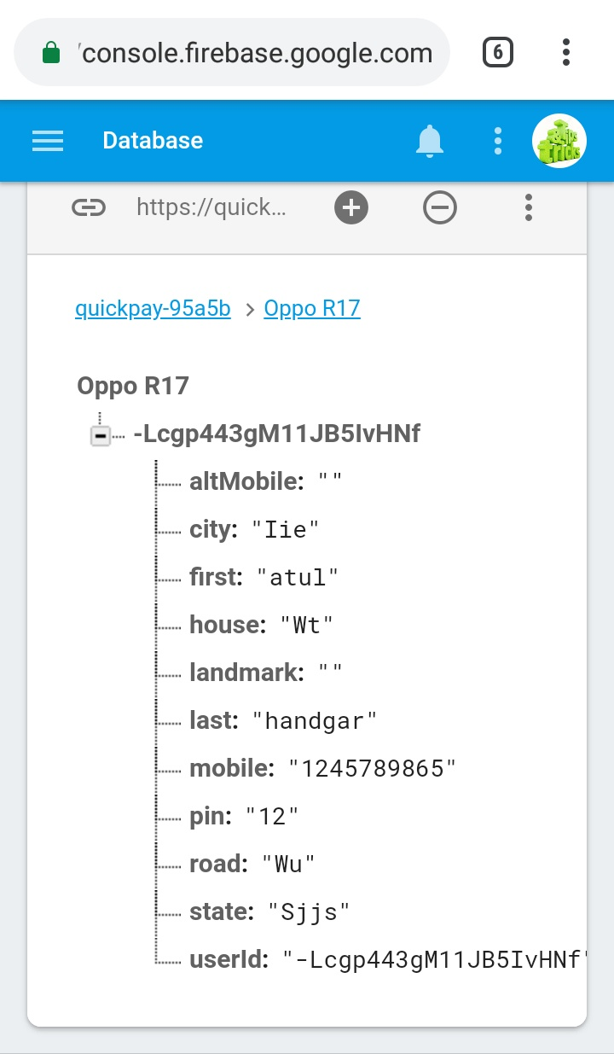

FIG-11 POPULAR PRODUCTS FIG-12 MOBILE DOCUMENTS

**DOCUMENTS**

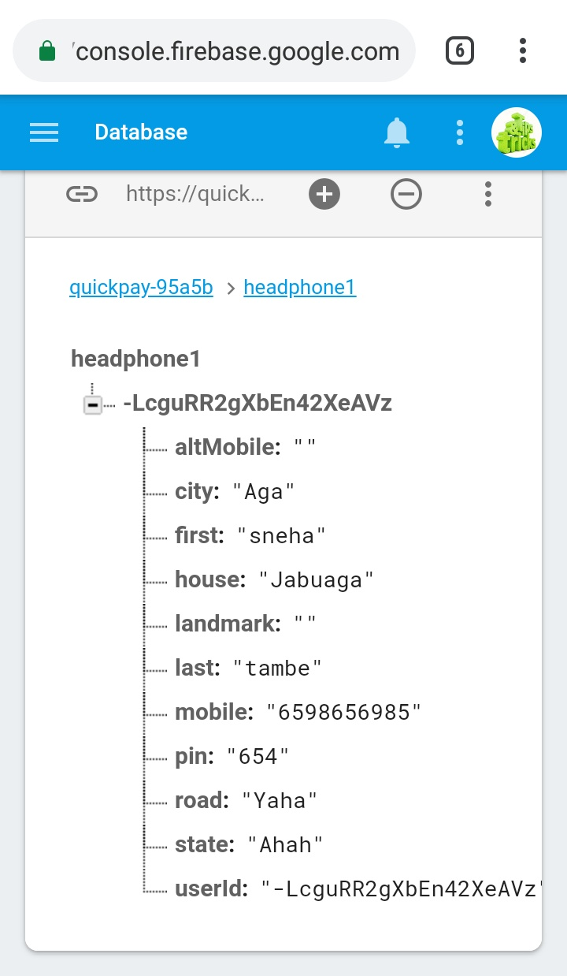 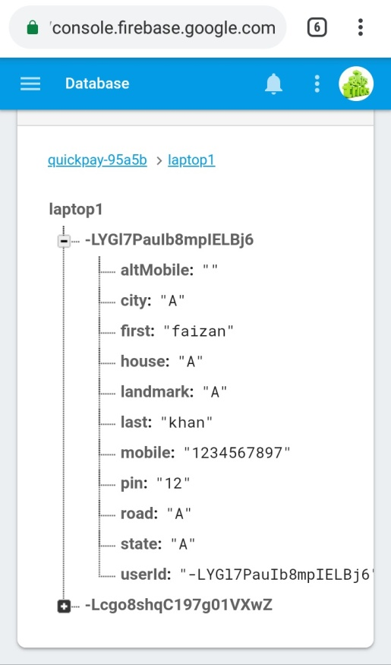

FIG-13 HEADPHONE FIG-14 LAPTOP DOCUMENTS